**Pizza sales SQl Queries**

A.Kpi’s

1.Total Revenu:

select *from pizza_sales_table;

select count(*) from pizza_sales_table;

select cast(sum(total_price) as decimal(10,2)) as total_sales from pizza_sales_table;



2.Avg Order Value:

select *from pizza_sales_table;

SELECT SUM(total_price) / COUNT(DISTINCT order_id) as avg_order_value

FROM pizza_sales_table;



3.Total pizza sold:

SELECT SUM(quantity) as total_pizza_sold FROM pizza_sales_table;



4.Total orders:

select *from pizza_sales_table;

select count(DISTINCT order_id) as total_orders from pizza_sales_table;

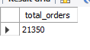

5.Avg Pizza per order:

select *from pizza_sales_table;

select cast(sum(quantity)/ COUNT(DISTINCT order_id) as decimal(10,2)) as avg_pizza_per_order from pizza_sales_table;



B.Chart Requirements:

1.Daily trend for total Orders:

SELECT DAYNAME(order_date) AS order_day,

COUNT(DISTINCT order_id) AS total_orders,

CASE

WHEN DAYOFWEEK(order_date) = 1 THEN 7 -- Sunday → 7

ELSE DAYOFWEEK(order_date) - 1 -- Monday (2) → 1, ..., Saturday (7) → 6

END AS sort_day

FROM pizza_sales_table GROUP BY order_day, sort_day ORDER BY sort_day;

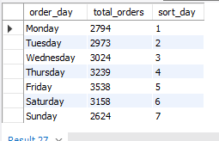

2.Monthly trend for total Orders:

SELECT monthname(order_date) AS order_month,

COUNT(DISTINCT order_id) AS total_order FROM pizza_sales_table

GROUP BY monthname(order_date);

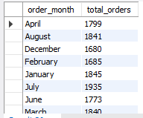

3.Percentage of sales by pizza category:

SELECT pizza_category,ROUND(SUM(total_price) * 100 / (SELECT SUM(total_price)

FROM pizza_sales_table), 2) AS percentage_of_sales FROM pizza_sales_table

GROUP BY pizza_category;

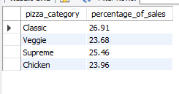

4.Percentage of sales by pizza size:

SELECT pizza_size,ROUND(SUM(total_price) * 100 / (SELECT SUM(total_price)

FROM pizza_sales_table), 2) AS pct FROM pizza_sales_table GROUP BY pizza_size order by pct desc;

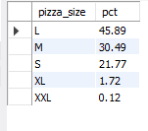

5.Total pizza sold by pizza category:

SELECT pizza_category, SUM(quantity) AS total_pizzas_sold FROM pizza_sales_table GROUP BY pizza_category;

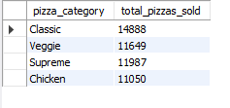

6.Top 5 best sellers by Revenue,total quantity and total orders:

SELECT pizza_name_id, SUM(total_price) AS Revenue,SUM(quantity) AS Total_Quantity, COUNT(DISTINCT order_id) AS Total_Orders FROM pizza_sales_table

GROUP BY pizza_name_id

ORDER BY Revenue DESC LIMIT 5;

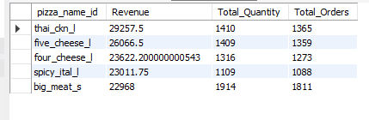

7.Bottom 5 best sellers by Revenue,total quantity and total orders:

SELECT pizza_name_id, SUM(total_price) AS Revenue, SUM(quantity) AS Total_Quantity, COUNT(DISTINCT order_id) AS Total_Orders FROM pizza_sales_table GROUP BY pizza_name_id ORDER BY Revenue asc LIMIT 5;

